**Multi-Site Supported Cloud Front CDN Implementation V1.0**

By Vikash Raaj

Contents

Drawbacks of Existing tools 3

Advantages of Multi Site Cloud Front Plugin 3

Environment Supported. 3

Installation Steps 3

Web.config change 3

Package Installation 4

System Settings 4

How to use 5

Ribbon Menu in Content Editor 5

Find Missing Item 6

Item [To Create] 6

Item with Children [To Create] 6

Item [To Clean S3] 6

Item with Children [To Clean S3] 6

Entire Master 6

Entire Web 6

Cloud Front Template 6

Base Template. 6

Where to Inherit 7

Site Specific Properties 7

Media Item Fields 8

Cache Name 8

Code Base 8

Next Level Work 8

Support 8

# Drawbacks of Existing tools

* No option to support different CNAME for media for each site.
* Single CDN url for all sites
* Master\preview doesn’t have CDN URL.
* Single item push, Folder level push, clean up features together won’t be available.

# Advantages of Multi Site Cloud Front Plugin

* Support for different CDN Domain for each Micro Site in Sitecore
* Option to allow default CDN Url if not available for the micro site.
* Enable\Disable at Site level, global level & Web.Config level.
* Ability to clean the CDN of Master, Web sync folder separately and clean out old unused files.
  + Either admin or a user with a Role can do the same.
* Media Item, Or All Descendents can be synced or cleaned out.
* CDN Maintained at versioning with language, version no and last updated at.
* Ability to select what type of item needs to be moved and loaded from CDN

# Environment Supported.

Currently the installable will support only **Sitecore 9.1 update 1 version**, if you need to make use of the same at some other version, you are required to **download the latest code base from GitHub** and then change the dependent dll, & solution version and generate the DLL.

# Installation Steps

## Web.config change

* Add the App Settings as below.

|  |  |  |
| --- | --- | --- |
| **Key** | **Value** | **Comment** |
| CDNEnabled | Yes | To Enable CDN At server |
| env:define | Dev, Uat, Prod, etc | Make sure this value is matching to the Environment in Sitecore Item. |

* Search for below and replace with the content marked with yellow Background.

<add verb="*" path="sitecore_media.ashx" type="Sitecore.Resources.Media.MediaRequestHandler, Sitecore.Kernel" name="Sitecore.MediaRequestHandler" />

<add verb="*" path="sitecore_media.ashx" type="Amgen.Foundation.MediaCdn.Handler.CustomMediahandler, Amgen.Foundation.MediaCdn" name="Sitecore.MediaRequestHandler" />

* Add the below on marked access-control-allow-origin, so that cross origin CSS, JS, Fonts file are allowed to load. This is not mandatory, but required to allow cross communication between the Domains.

<system.webServer>

<httpProtocol>

<customHeaders>

**<add name="Access-Control-Allow-Origin" value="*" />**

</customHeaders>

</httpProtocol>

</system.webServer>

## Package Installation

Install the provided package in Sitecore Instance as below.

* Multi-Site Cloud Front CDN-V1.0.zip 🡪Contains all Sitecore item change.
* Sc9.1.1 - PhysicalFiles.zip 🡪 Contains the physical Files to deploy in CD\CD instance of Sc9.1.1 Version

### System Settings

We need to set the settings in System ->Modules ->Media CDN post to package installation and create the environment based items that has S3 bucket access

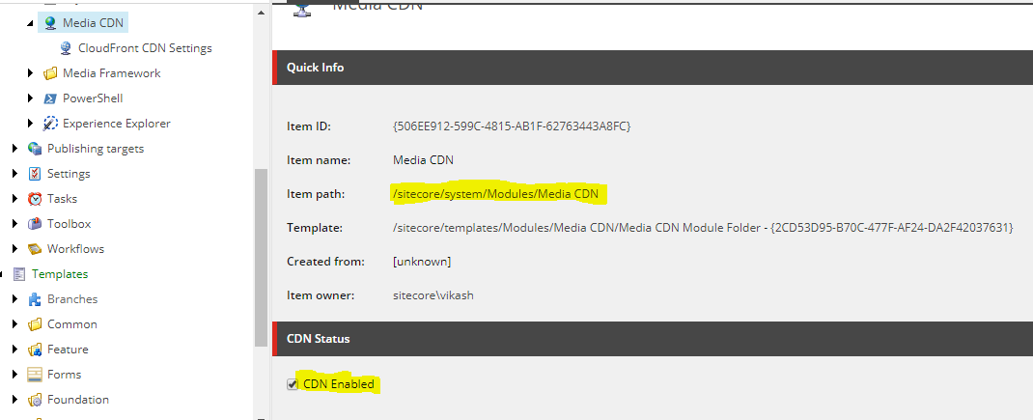

Create the Environment specific S3 Bucket Details and the Default CDN Url to use if Site level URL doesn’t Found.

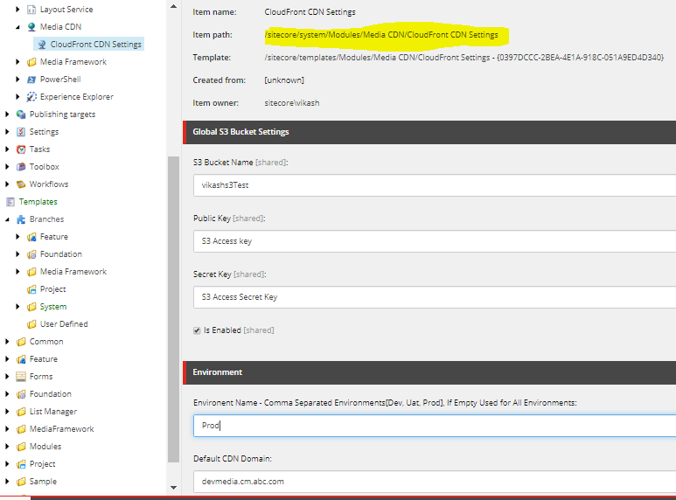

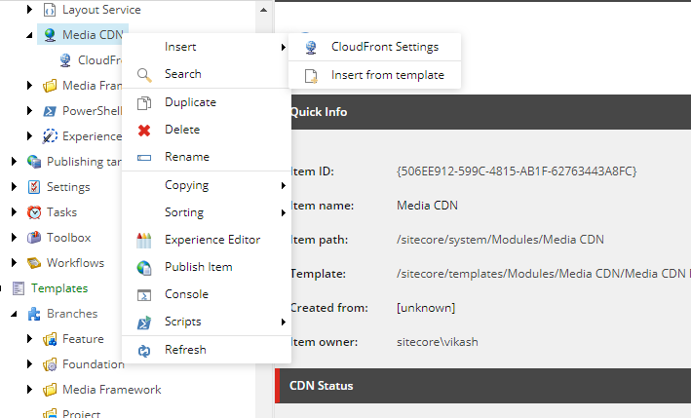

# How to use

## Ribbon Menu in Content Editor

We have added a new tab in Content editor for Cloud Front and it has couple of features to perform.

Below Screenshot Helps to Show where the menu would be loaded.

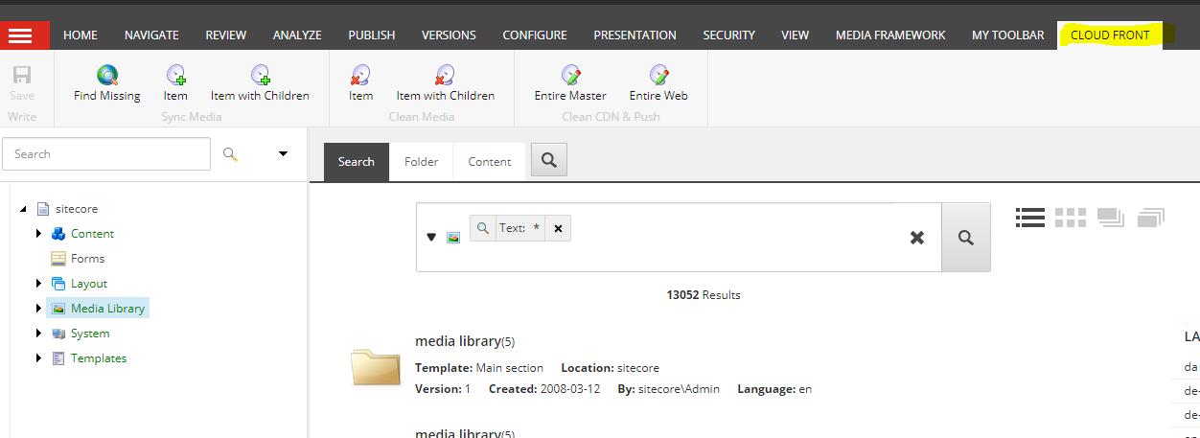

Sub Menu of the Cloud Front to show clearing what is present

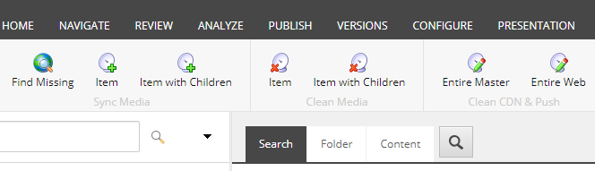

Below is provided in sequence to the above image order, to explain the purpose of each icon in Content Editor.

### Find Missing Item

This helps to find all yet to Sync items on the Media Library, this really helps to find any is missed to sync out which has inherited our base template.

### Item [To Create]

To Sync to CDN only the particular Item on all version and language if the item template has inherited the base template and update the CDN URL in Sitecore.

### Item with Children [To Create]

To Sync to CDN the selected Item and its children on all version and language for which item template has inherited the base template and update the CDN URL in Sitecore for each.

### Item [To Clean S3]

To clean the CDN only the particular Item on all version and language if the item template has inherited the base template and update the CDN URL to empty in Sitecore.

### Item with Children [To Clean S3]

To Sync to CDN the selected Item and its children on all version and language for which item template has inherited the base template and update the CDN URL to empty in Sitecore for each removed item of S3.

### Entire Master

Clean out the Master item inside the S3 Bucket and write the files for all items that has the URL of CDN in master db. This is used to wipe out all items and have only the current tree items, very useful to clean up space in lower environment. When we perform this operation, **we need to disable the CDN at master in System 🡪Modules🡪CDN** settings so that images won’t break to all sites which uses master database as source.

### Entire Web

Clean out the Web item inside the S3 Bucket and write the files for all items that has the URL of CDN in web db.. This is used to wipe out all items and have only the current tree items, very useful to clean up space in lower environment. When we perform this operation, **we need to disable the CDN at master in System 🡪Modules🡪CDN settings and publish to web** before doing this operation, so that images won’t break to all sites which uses web database as source.

# Cloud Front Template

## Base Template.

There are 2 templates, which has to be inherited to the media templates that needs to be loaded from CDN automatically. Media has 2 types versioned and versioned. So inherit as per the need, current demo shows to inherit to all media Items.

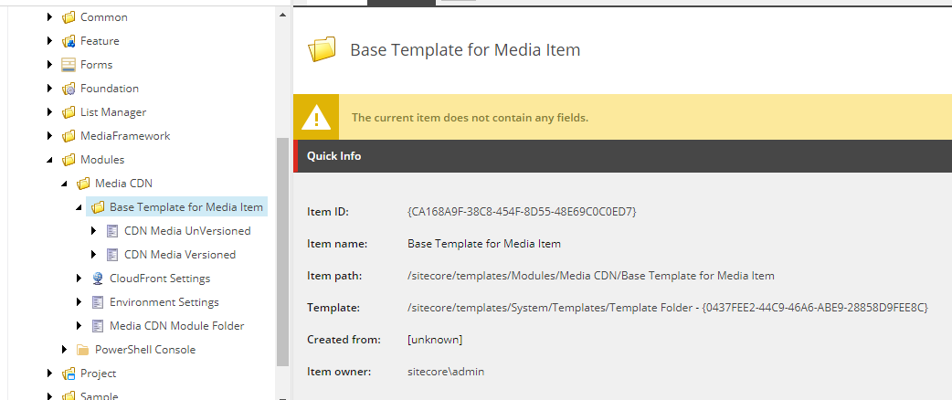

## Where to Inherit

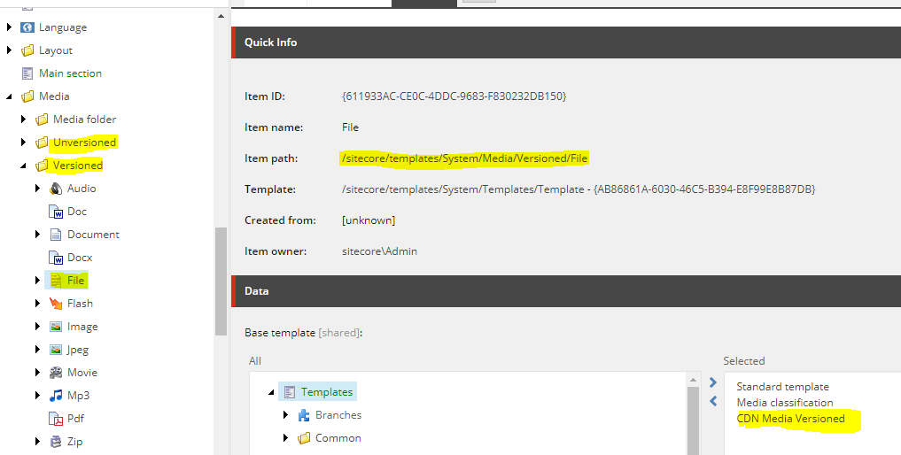

### Site Specific Properties

Each Site level we need to create some properties and update the same to maintain the CDN to load or not and what URL to use for the same.

|  |  |  |
| --- | --- | --- |
| **Key** | **Value** | **Reason** |
| CdnDomainUrl | <http://cdn.domain.com> | To use as the CDN Domain for media |
| CanPrefixCdnAsSubDomain | Yes | This will append <https://cdn>. To the current URL and makes  <https://cdn.domain.com> if CdnDomainUrl value not found. |
| IsCdnEnabled | True | To Use CDN for the Site |

## Media Item Fields

When the item is synced to CDN, the Field value on

* **UrlOnCDNServer** has the s3 bucket URL
  + Actual URL for Master would be <CdnDomain>/master/FieldValueOfUrlOnCDNServer
  + Actual URL for web would be <CdnDomain>/master/FieldValueOfUrlOnCDNServer
* **Cdn Synced ON**, show when the last sync performed on.
* **Ignore CDN On Load**, when this is checked the item wont load from CDN, this is provided a facility to avoid the particular item to skip from loading under CDN.

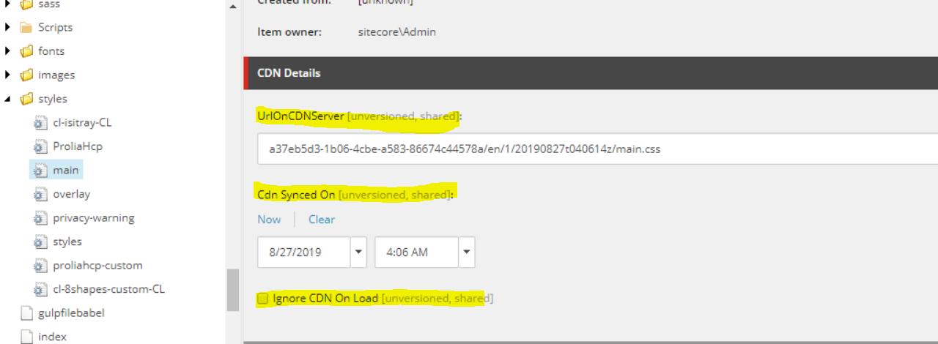

## Cache Name

CloudFront uses a cache for maintaining the S3 bucket information in cache instead of hitting Sitecore every time. This is usefull to know whether the S3 Bucket information are stored inCache for processing media Item or not.

Cache key 🡪 CloudFront

# Code Base

Code has been released as Open source in GitHub @ <https://github.com/vikashinchennai/CloudFront-MultiSite>

Changes or upgrade are welcome on the plugin

# Next Level Work

Currently working on the CDN on Azure, Google, Akamai for Sitecore which can also help some customers who are not in AWS but different platform.

# Support

Feel free to reach to be in Git or directly for any support or ideas,